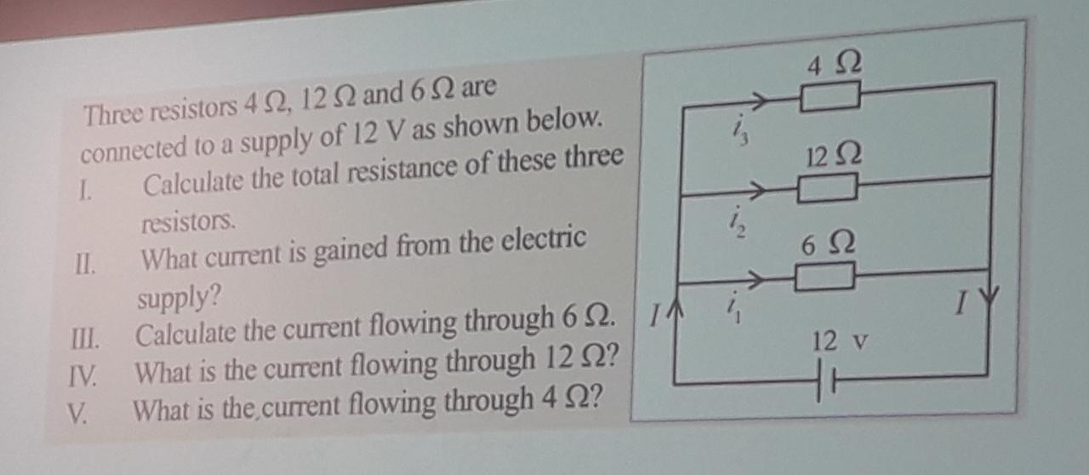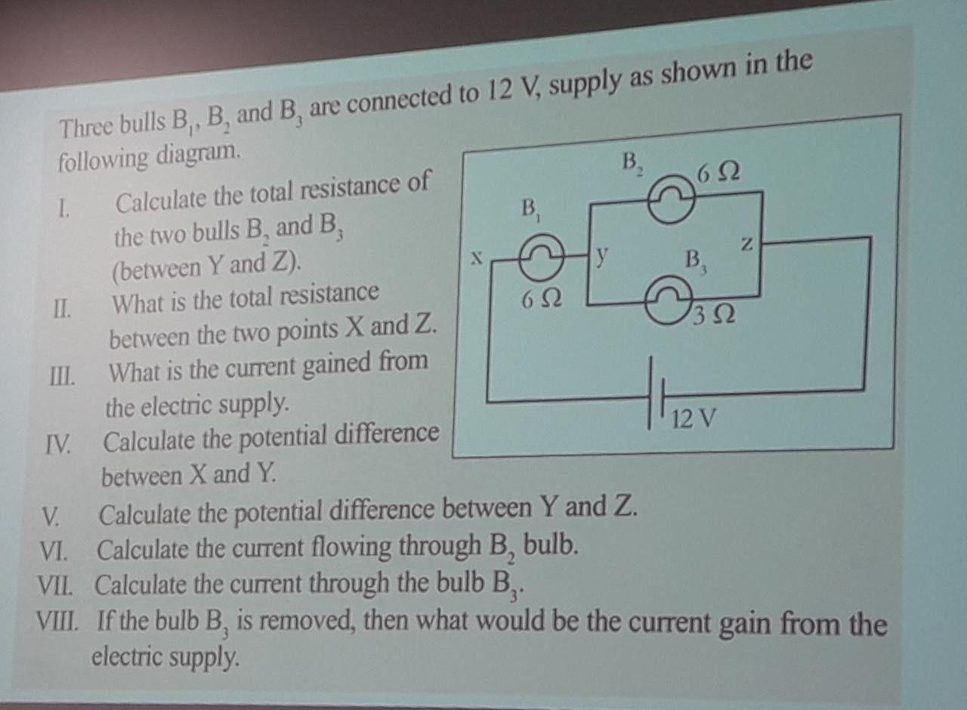

Answers

01.

|  |
| --- |
| 1. 1/R = 1/R1 + 1/R2 + 1/R3   =1/4 +1/12+1/6  =6/12  =1/2  R = 2 ohms |
| 1. V=IR   12= I*2  I = 6A |
| 1. V=IR   12= I*6  I = 2A |
| 1. V=IR   12= I*12  I = 1A |
| 1. V=IR   12= I*4  I = 3A |

02.

|  |
| --- |
| 1. 1/R= 1/6+1/3   1/R = 1/2  R = 2 ohms |
| 1. R= (6+2) ohms   R= 8 ohms |
| 1. V=IR   12 =I*8  12/8= I  1.5A=I |
| 1. V=IR   V=1.5*6  V=9V |
| 1. V=IR   V=1.5*2  V=3V |
| 1. V=IB2   3=I*6  I=0.5A |
| 1. V=IB3   3=I*3  I=1A |
| 1. V=IR   12=I*12  I=1A |